**Student Guide**

2021-2022

**Contents**

|  |  |  |
| --- | --- | --- |
| **S/N** | **Index** | **Page No.** |
| **1** | **A Word from the Dean** |  |
| **2** | **A Word from the Manager of Education Quality Assurance Unit** |  |
| **3** | **Faculty of Medicine Overview** |  |
| **4** | **Formation of Education Quality Assurance Unit** |  |
| **5** | **The Vision** |  |
| **6** | **The Mission** |  |
| **7** | **The Organizational Structure** |  |
| **8** | **The Specifications of Al Azhar Faculty of Medicine Graduates** |  |
| **9** | **The Heads of Departments** |  |
| **10** | **The bylaw of Al Azhar Faculty of Medicine** |  |
| **11** | **The academic grades given by the faculty** |  |
| **12** | **The Study System** |  |
| **13** | **The College Departments** |  |
| **14** | **The Curriculum Codes** |  |
| **15** | **Rules for transferring from college to other colleges** |  |
| **16** | **The Financial Aid Guide and Student Loans** |  |
| **17** | **Tuition fees for students** |  |
| **18** | **Student Accommodation and Admission Requirements in University City** |  |
| **19** | **Student Health Care** |  |
| **20** | **Student Activities** |  |
| **21** | **Social Solidarity System** |  |
| **22** | **Excellence Award Conditions** |  |

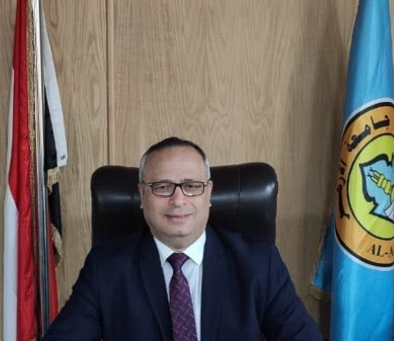

**Prof. Dr. Hussein Abu Al Ghait**

**Dean of the Faculty**

**A Word from the Dean**

**Dear Students of Al Azhar faculty of medicine, I am pleased to present to you this student guide as a beacon, to get you to know your faculty and professors, and to give the needed information about the study schedules, exams’ schedules and systems and all what you need to know. Trust that our goal as a faculty staff, including the honorable academic personnel, and all the working members in the faculty, is to elevate you scientifically, intellectually, and culturally, setting the right climate to achieve this goal, committing together with the college spirit and the medical ethics, and seeking to reach the best quality degrees, for our faculty to be put in the place it deserves as one of the best faculties of medicine in our region of world.**

**This only could be achieved with your cooperation and diligence, dear students, in maintaining the safety of faculty’s laboratories and terraces, and through your kind spirit to gain knowledge, manifesting the good manners inside and outside the faculty, and showing a good example of committed student bearing the profession ethics, and who respects his professors and know how to communicate exemplary with the other faculty staff members.**

**All my gratitude and appreciation for the quality unit and for everyone contributed to issue this guide. As I would like to draw your attention that all the information mentioned in this guide, along with other useful information are available on faculty’s website mentioned in this guide. We invoke Allah Almighty to bless our college and our beloved homeland Egypt.**

**Dean of the Faculty**/ **Prof. Dr. Hussein Abu Al Ghait**

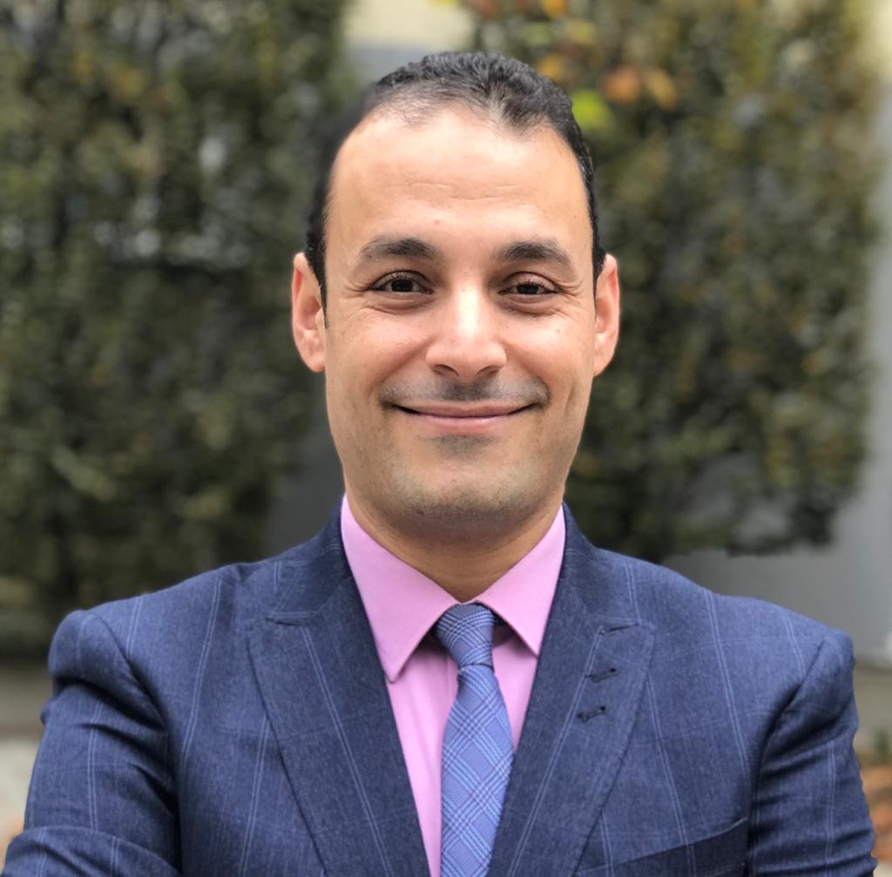

**Prof. Dr. Faisal Zayed**

**Manager of Education Quality Assurance Unit**

**A Word from Prof. Dr./ Manager of Quality Assurance Manager**

**Future Fellow Colleagues, students of Al Azhar faculty of medicine, it is my pleasure to welcome you and introduce to you this guide. In which, you will find, my dear students, everything related to the student services, welfare and activities, as Al Azhar university is one of the oldest universities, and faculty of medicine, which was established in 1961, leans on long heritage and experience in terms of serving the students and providing the suitable environment to them to study and gain knowledge. The student services and activities were developed in the last few years to be in a line with the new vision of the faculty and its quest for globalization and graduating unique qualified doctors.**

**Aristotle said, “We are what we repeatedly do, Excellence, then, is not an act, but a habit”. That is why through the education quality assurance unit, we are strively seeking to achieve excellence by constant hard work. Within the strategic plan of the education quality assurance, the unit has approved new developmental initiatives and projects aiming to achieve the faculty vision and mission. The development should not be temporary, rather permanent, looking to the future in a constant movement. We, at the quality unit, are looking upon a big response from our students, to hear from them, to know their opinions, and to listen to their purposeful criticism, as what is really helping us to develop and improve is these points of view and these trends of our students.**

**Best wishes for continuous success and to be the best ambassadors for the oldest university**

**Prof. Dr. Faisel Zayed**

**Manager of Education Quality Assurance Unit**  
  
  
  
**Faculty of Medicine Overview**

**Al Azhar faculty of medicine was established as one of the practical colleges in Al Azhar University under the law no. 103 issued in May 1961 on reorganizing Al Azhar and its institutions.**

**In 1964, the cornerstone of the faculty was laid in Nasr city, Cairo. Besides the regular study of the faculty; having the same as all other medicine schools in Egyptian universities in terms of teaching the medical subjects and providing scientific researches in the field of treatment, prevention and providing health care for patients, Al Azhar faculty of medicine is distinguished from its other fellow medicine schools by teaching the Islamic subjects which are decided by the university administration, as it is also interested in expressing and spreading the Islamic Arab Medical heritage, preserving the high Islamic values and providing the students with what would benefit them in their religion and knowledge.**

**From this standpoint, the aim of establishing this great faculty is to present the homeland and the whole Islamic world with religious doctors whom, beside being proficient in the various medical sciences, are very well versed in terms of jurisprudence (Fiqh), doctrine (Aqidah), Islamic laws, prophetic sayings (Hadiths), Quran, in order to consolidate the link between religion and life, so they would invite to the way of Allah with wisdom and good preaching.**

**Al Azhar University put a bylaw for faculties of medicine according to the decision of the Grand Imam of Al Azhar no 914 of 1990, in addition to the following decisions as per the resolution issued by the supreme council of Al Azhar no 149 of 2003**

**The purpose of this bylaw is to indicate the practical departments of the faculty, and to specify the divisions of specializations, the departments of studies and the branches of practical degrees and the detailed requirements to each one of them. One of the purpose of this bylaw also is to define the study system, set forth the academic courses and its schedule throughout the years of study, to set the allocated hours to each one of them, and to set the rules for exams, so that the study achieves the healthy goals of the state and the needs of the society.**

**Formation of Education Quality Assurance Unit**

**Members of Faculty Board**

|  |  |
| --- | --- |
| Prof. Dr. Hussein Abu Al Ghait | The Dean – The President of the Unit Board of Directors |
| Prof. Dr. Khairy Abdel Hamid Muhammad | The Vice Dean for Student and Learning Affairs & Vice President of Education Quality Assurance Unit Board of Directors |
| Prof. Dr. Muhammad Abdel Aziz Al Zayat | The Vice Dean for Postgraduate and Research Affairs & Vice President of Education Quality Assurance Unit Board of Directors |
| Prof. Dr. Ahmad Muhammad Selim | The Former Dean |
| Prof. Dr. Faisal Hassan Zayed | Professor of Orthopaedic Surgery – Manager of Quality Assurance Unit |
| Prof. Dr.Mustafa Abdel Naser Ali | Professor of Microbiology and Immunology - Honorary Chair and Unit Adviser |
| Prof. Dr. Yasser Helmy | Professor of Plastic Surgery and Manager of Scientific Research Unit |
| Prof. Dr. Wajeeh Mansour | Manager of the Integrative Medical Education Unit |
| Prof. Dr. Najeh Mabrouk | Manager of the Measurement and Calendar Unit |
| Prof. Dr. Ahmed Said Bayoumi | Director of E-Learning Unit |
| Prof. Dr. Mustafa Abdel Hamid Abu AL Enein | Head of Emergency and Critical Medicine Department and Manager of Crisis and Disaster Management Unit |
| Prof. Dr. Yousra Ragab Abdel Hamid | Professor of Rheumatology and Rehabilitation and Head of the Department of Geriatrics - Administrative Staff Standard |
| Dr. Ahmad Hassan Al Said Nouh | Lecturer of Dermatology - Deputy Director of the Quality Unit |
| Dr. Mohamed Zein Al Abidin Yousef | Assistant Lecturer, Department of General Pathology |
| Dr. Muhammad Abdel Aziz Doumah | Biochemistry Lecturer |
| Dr. Osama Mustafa Abdel Razek | Lecturer of Hepatology and Gastroenterology - Strategic Planning Standard |
| Dr. Mustafa Mahmoud Rabie | Lecturer of Public Health – Governance and Leadership Standard |
| Dr. Muhammad Gaber Kishka | Demonstrator of Pharmacology - Standard of Faculty Members |
| Dr. Lutfy Muhammad Ali Suleiman | Lecturer of Orthopedic - Standard of the Administrative Body |
| Dr. Hatem Galal Abdallah | Lecturer of Rheumatology and Medical Rehabilitation - Standard of Financial and Material Resources |
| Dr. Abdaalah Hassan Mallah | Lecturer of Vascular Surgery – Standard of Academic Measurements and Educational Programs |
| Prof. Dr. Ahmad Mahmoud Al Sherfi | Assistant Lecturer of Neurosurgery – Standard of Scientific Research |

**Consultants**

|  |  |
| --- | --- |
| Prof. Dr. Shahinaz Mahmoud Hussein | Professor of Pediatrics – AL Azhar University |

**Social Parties:**

|  |  |
| --- | --- |
| Prof. Dr. Osama Abdel Hay | Secretary General of the Egyptian Medical Syndicate |
| Dr. Muhammad Ali AL Borai | Member of Doctors' Syndicate in Cairo |
| Prof. Dr. Ibrahim Jamil Muhammad Owais | Member of the Parliament |
| Dr. Mahmoud Farouk Farrag | Pharmacy- CEO of Park Ville |

**Faculty Administrative Departments**

|  |  |
| --- | --- |
| **Prof. Khalid Adel Abdel Khaleq** | **General Manager of the Faculty** |

**Internship Doctors**

|  |  |
| --- | --- |
| Omar Al-Samri | **01020945886** |

**Students:**

|  |  |
| --- | --- |
| Khaled Mohamed Mohamed El-Sayed Qandil | **Fourth Year – 01006879868** |

**The Vision**

“**For Al Azhar faculty of medicine for boys to reach globalism in the unique field of medical learning and scientific research in order to provide a unique community service in the frame of moderate Islamic culture**”

The updated vision and mission were approved during the faculty’s council no 706 on 28 June 2021

**The mission**

**“Al Azhar faculty of medicine for boys commits to prepare scientifically qualified doctors who are able to provide outstanding health care, in addition to continuous development for the educational process and distinguished scientific research in order to meet the international standard for doctors to face community health problems in efficiently and aptly in the light of moderate Islamic culture by:**

1. Adopting an integrative education strategy for the bachelor student based on combining basic medical sciences with clinical sciences since the beginning of the study program
2. Excelling in the areas of scientific research related to the health problem on a global level.
3. Providing medical and research education opportunities for the postgraduate students to promote the academic and occupational levels.
4. Providing health care and spreading health awareness to serve the community on both national and international levels.

The updated vision and mission were approved during the faculty council no 706 on 28 June 2021

­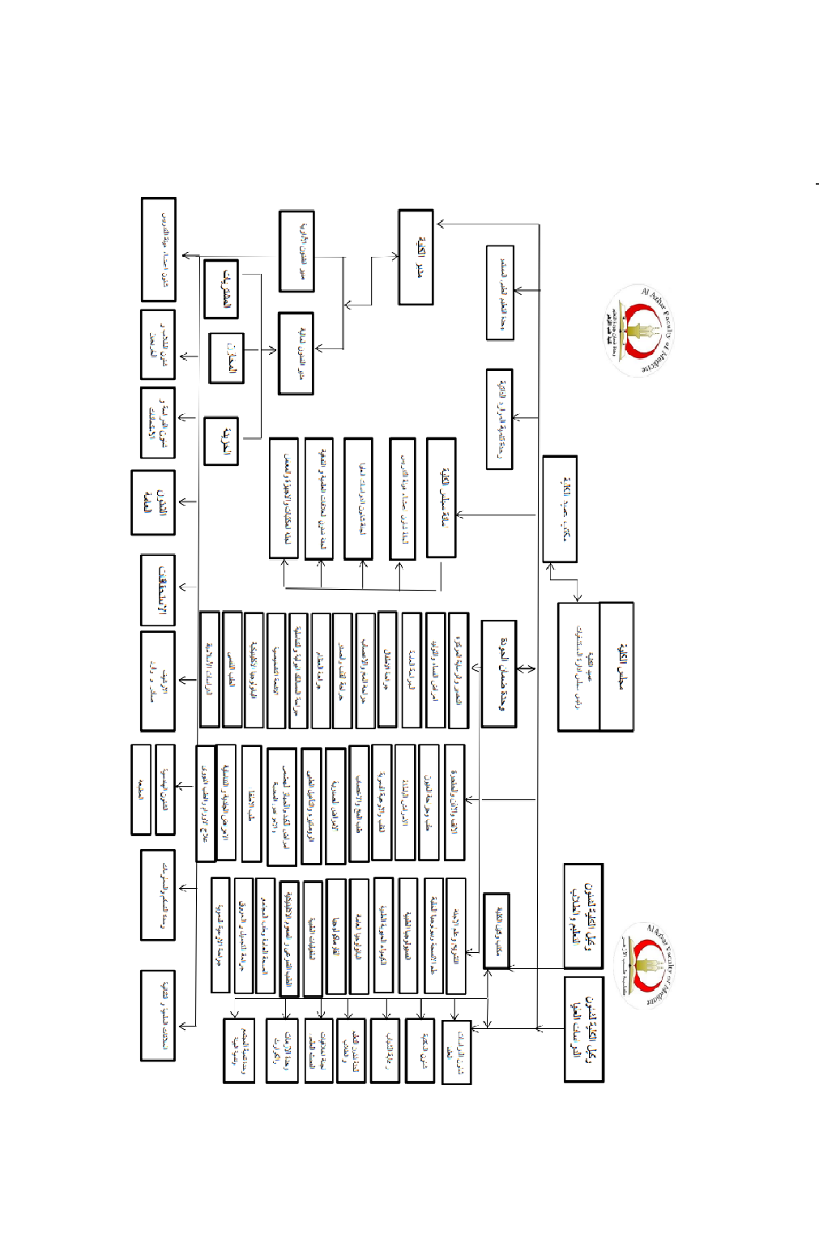

**Specifications of Al Azhar Faculty of Medicine Graduate**

Al Azhar faculty of medicine graduates doctors with the following specifications:

1. Providing primary health care services and preventive medicine, and enhance the patient safety with the ability to co-work with primary and secondary health care staffs.
2. Work on maintaining health system and raise the level of human wellbeing.
3. Acting professionally and committing to the principles of medical ethics from an Islamic perspective.
4. Valuing the doctor-patient relationship and ensuring its continuity.
5. Working effectively with other medical staff members and respect their roles.
6. Acknowledging his role in the medical system based on his vocational position and using his leading skills to enhance the performance of the medical system.
7. Contributing in developing and improving the environment.
8. Strengthening student personality and self-confidence in order to have the ability of making decision and working through critical situations.
9. Having good manners with others and filing reports.
10. The ability of self-learning and gaining more medial knowledge to improve and raise their knowledge.
11. Practicing critical thinking and having the ability of creative thinking to solve health issues.
12. The skill of reaching the best-published knowledge in the field of medicine with evaluation and application of the best supported proves and evidences.
13. The awareness of the economic, environmental, psychological, social, ethical and professional determinants in the areas of health and disease.
14. Maintaining professional standards and adhering to the professional custom with patients and relatives.
15. The ability of teaching others with maintaining professional engagement and good team spirit.
16. Preserving the rules of the moderate Islamic culture during practicing his job.

**Heads of the Departments**

|  |  |  |
| --- | --- | --- |
| 1 | Anatomy and Embryology Department | Prof. Dr. Mohamed Abdel Hai Otifi |
| 2 | Histology Department | Prof. Dr. Tamer Massad Mahmoud |
| 3 | Department of Medical Physiology | Prof. Dr. Shibl Ramadan Ali Samaha |
| 4 | Department of Medical Biochemistry | Prof. Dr. Khairy Abdel Dayem |
| 5 | Department of General Pathology | Prof. Dr. Sayed Abdel Rahim Sayed Ali Durai |
| 6 | Department of Pharmacology | Prof. Dr. Abdel Latif Saad Abdel Latif |
| 7 | Parasitology department | Prof. Tarek Khamis Ibrahim |
| 8 | Department of Microbiology and Immunology | Prof. Dr. Essam Abu Al-Yazid |
| 9 | Department of Community Medicine and Industrial Medicine | Prof. Dr. Osama Abdulaziz Mohamed |
| 10 | Department of Forensic Medicine and Clinical Toxicology | Prof. Dr. Fouad Helmy El-Sayed El-Dabbah |
| 11 | Department of Internal Medicine | Prof. Dr. Magdy Al-Dahshan |
| 12 | Department of General Surgery | Prof. Dr. Magdy Mahmoud Mustafa Ali |
| 13 | Department of Anesthesia and Intensive Care | Prof. Ayman Hussein Fahmy Muhammad Kahla |
| 14 | Department of Obstetrics and Gynecology | Prof. Dr. Hossam El Din Fahim Abdel Rahim Ahmed |
| 15 | Department of Dermatology, Venereology and Andrology | Prof. Dr. Mohamed Ahmed Abdel Rahman Al-Khalwany |
| 16 | Department of Cardiovascular Diseases | Prof. Dr. Mansour Mohamed Mostafa |
| 17 | Chest Diseases Department | Prof. Dr. Mohamed Sedky El-Sayed |
| 18 | Neurology Department | Prof. Dr. Sayed Ahmed Fathy Abdel Hamid Al-Zayat |
| 19 | Department of Hepatology and Gastroenterology | Prof. Dr. Abdo Mabrouk Abdo El Shafei |
| 20 | Naturopathy, Rheumatology and Rehabilitation Department | Prof. Dr. Abdel Hamid Abdel Haris Khalil |
| 21 | Department of Ear, Nose and Throat Surgery | Prof. Dr. Ali Khalaf Mahrous |
| 22 | Urology Department | Prof. Dr. Ahmed Fahem Abdel Rahim |
| 23 | Department of Orthopedic Surgery | Prof. Dr. Ismail Ahmed Yassin |
| 24 | Department of Ophthalmology | Prof. Dr. Ahmed Mohamed Salah El Din |
| 25 | Department of Pediatrics | Prof. Dr. Ahmed Youssef Youssef Ibrahim Al-Sawah |
| 26 | Diagnostic Radiology Department | Prof. Dr. Abdullah Muhammad Muhammad Ahmad Al-Khashin |
| 27 | Clinical Pathology Department | Prof. Dr. Yousra Zaki Ali Al-Zuhairi |
| 28 | Department of Psychiatry and Addiction Treatment | Prof. Dr. Abdel Hadi Issa Hassan |
| 29 | Neurology Department | Prof. Dr. Hamdy Mohamed Hussein |
| 30 | Cardiothoracic Surgery Department | Prof. Dr. Al-Husseini Al-Husseini Al-Sayed Jamil |
| 31 | Plastic Surgery Department | Prof. Tariq Mahmoud Youssef Al-Banouby |
| 32 | Department of oncology and nuclear medicine | Prof. Wael Helmy El-Shishtawy |
| 33 | Islamic Studies Department | Prof. Dr. Anas Abdel Fattah Ahmed Abu Shady |
| 34 | Vascular surgery department | Prof. Dr. Mohamed Abdel Hamid Abdel Rahman Gomaa |
| 35 | Department of Oncology Surgery | Prof. Dr. Said Hosny Bandary |
| 36 | Pediatric Surgery Department | Prof. Dr. Ashraf Hamed Seddik |
| 37 | Department of Emergency Medicine and Critical Cases | Prof. Dr. Mustafa Abu Al Enein |
| 38 | Geriatric Department | Prof. Yousra Rajab Abdel Hamid |

**The bylaw of Al Azhar faculty of medicine for boys**

The faculty accepts the Muslim students from Egypt and the entire world:

* The Egyptian Students: The admission is limited to student who have Al Azhar secondary education certification – Scientific division (the first and the second round), and the admission is decided by admission coordination office at AL Azhar university.
* The International Students: They are accepted after being presented to Honorable professor president of Al Azhar University.

**The bylaw at Al Azhar faculty of medicine for boys includes the following:**

1. **The academic grades given by the faculty:**

|  |  |
| --- | --- |
| Bachelor of Medicine and Surgery | The duration of study is 5 years followed by 24 months as an intern doctor |
| Specialization (Higher) Diploma (In every medical sciences) | Courses for one year |
| Master’s degree in Specialization (in every medical sciences) | 2 years as minimum which include courses and research |
| Doctorate in Specialization (in every medical sciences) | 2 years as minimum which include courses and research |

2- Study System:

**One: (Credit Hours System)**

The philosophy of credit hours system depends on the resilience with the educational system and the curriculum that the student studies throughout the semester, beside it gives him the freedom to choose the courses to the extent that ensures the smooth conduct of the educational process in a way that does not contradict the available capabilities and the special nature of each department. In the end, the student is objectively evaluated to get a competent graduate capable of competing in the labor market.

What is the meaning of Credit hours? Credit hours is a measurement unit for the numbers of hours that the student should attend to a certain course during a semester. The credit hour equals:

- Theoretical lectures: One hour a week for 15 weeks: 15 hours

- Practical sessions: 2 hours a week for 15 weeks: 30 hours

- Clinical sessions: 3 hours a week for 15 weeks: 45 hours

- Field activities: actual 4 hours a week for 15 weeks: 60 hours

*Calculation of scores of credit hours:*

One Credit Hour= 25 scores

**Two: Study Language**

1. The English language is the main study language of the study program.
2. The Arabic language is used in medical ethics course and the modules of communication and discussion with patient, as it is also the language used to study the Islamic courses.
3. The non-Arabic speakers must finish the Arabic course in the first year, and it is upon the student to engage in Arabic courses to improve the speaking and listening skills in order to be ready to courses of consultancy skills and modules of communication and discussion with patients.

**Three: Attendance**

1. The student must attend theoretical, practical and clinical sessions, with an attendance rate of not less than 75% from the time scheduled for each subject. The faculty council also, upon the request of the relevant department council, has the right to deprive the student who didn’t meet this percentage from applying for the exam of this subject, unless the faculty council accepts his excuse, and provided that his attendance rate is not less than 50% of the time scheduled for each subject.
2. If the percentage of the absence exceeded 25% of the total numbers of the scheduled study hours, the student is deprived from the final exam, and he has to restudy the course. If the absence, however, is because of illness or for acceptable force majeure, then the student shall be considered withdrawn from the subject, and absence without failure shall be noted in his academic record.

**Four: The Study Environment**

Studying at Al Azhar Unmixed Faculty of Medicine

**3- Faculty Departments**

**Article (1): Al Azhar faculty of medicine for boys includes the following departments:**

|  |  |
| --- | --- |
| 1 | Anatomy and Embryology Department |
| 2 | Histology Department |
| 3 | Department of Medical Physiology |
| 4 | Department of Medical Biochemistry |
| 5 | Department of Pathology |
| 6 | Department of Pharmacology |
| 7 | Parasitology department |
| 8 | Department of Microbiology and Immunology |
| 9 | Department of Community Medicine and Industrial Medicine (including branches of public health, industrial medicine and occupational health) |
| 10 | Department of Forensic Medicine and Clinical Toxicology |
| 11 | Department of Internal Medicine |
| 12 | Department of General Surgery |
| 13 | Department of Anesthesia and Intensive Care |
| 14 | Department of Obstetrics and Gynecology |
| 15 | Department of Dermatology, Venereology and Andrology |
| 16 | Department of Cardiovascular Diseases |
| 17 | Chest Diseases Department |
| 18 | Neurology Department |
| 19 | Department of Hepatology and Gastroenterology |
| 20 | Naturopathy, Rheumatology and Rehabilitation Department |

|  |  |
| --- | --- |
| 22 | Department of Ear, Nose and Throat Surgery: It includes the following specialties (otolaryngology - audiology and speech pathology) |
| 23 | Urology Department |
| 24 | Department of Orthopedic Surgery |
| 25 | Department of Ophthalmology |
| 26 | Pediatric Department:  It includes the following specialties: (Genetics - hematology, tumors, bone marrow transplantation, newborns and premature babies - heart diseases - infectious diseases and nutrition - digestive system and liver - immunity and allergies - endocrinology and diabetes - critical cases and intensive care - kidney diseases - neurology) |
| 27 | Diagnostic Radiology Department |
| 28 | The Department of Clinical Pathology includes the following specializations: (Clinical Chemistry, Hematology, microbiology and immunology) |
| 29 | Department of Psychiatry and Addiction Treatment |
| 30 | Neurology department |
| 31 | Cardiothoracic Surgery Department |
| 32 | Department of oncology and nuclear medicine |
| 33 | Islamic Studies Department |
| 34 | Vascular surgery department |
| 35 | Department of Oncology Surgery |
| 36 | Department of Emergency Medicine and Critical Cases |
| 37 | Geriatric Department |
| 38 | Pediatric Surgery Department |

**Article (2): Courses Codes in the program**

The courses are named by letters and numbers.

1. The Courses which represent the study units and the transverse integration: 3 letters are put, which are (IMP) abbreviated from the English name "Integrated Medical Program"
2. Islamic Courses: 3 letters are put, which are (URR), and they abbreviated from the English name “University Religion Requirement”
3. Courses which are elective: 3 letters are put, which are (EAC) abbreviated from the English name “Elective Academic Course” and (ENC) abbreviated from the English name “Elective Non-Academic Courses”

**Second: Numbers**

- The Code of the faculties of medicine in the university is (07)

- Study year code is 07-1

- Semester code is 0-101

|  |  |  |  |
| --- | --- | --- | --- |
| م | **Module name** | **Credit hours** | **Course code** |
| 1 | Qur’an Kareem | 1 | URR-07-10101 |
| 2 | Fekh | 1 | URR-07-10102 |
| 3 | Normal human body | 7 | IMP-07-10103 |
| 4 | Principles of diseases and drug therapy | 4 | IMP-07-10104 |
| 5 | Biomedical sciences | 4 | IMP-07-10105 |
| 6 | Cellular and molecular biology and principles of genetics | 2 | IMP-07-10106 |
| 7 | Medical ethics | 1 | IMP-07-10107 |
| 8 | English and medical terminology | 1 | IMP-07-10108 |
| 9 | Elective (1) | 1 |  |
| 10 | aqeeda | 1 | URR-07-10209 |
| 11 | Computer science and information technology | 1 | IMP-07-10210 |
| 12 | Hematopoietic system and basic immunology | 4 | IMP-07-10211 |
| 13 | Musculoskeletal and skin | 8 | IMP-07-10212 |
| 14 | Research methodology and biostatistics | 2 | IMP-07-10213 |
| 15 | Respiratory system | 4 | IMP-07-10214 |
| 16 | Soft skills | 1 | IMP-07-10215 |
| 17 | Elective (2) | 1 |  |
| 18 | Qur’an Kareem | 1 | IMP-07-20316 |
| 19 | Cardiovascular system | 8 | IMP-07-20317 |

|  |  |  |  |
| --- | --- | --- | --- |
| **م** | **Module name** | **Credit hours** | **Course code** |
| 20 | Renal and urinary system | 5 | IMP-07-20318 |
| 21 | Behavioral and social sciences | 3 | IMP-07-20319 |
| 22 | Introduction to clinical skills | 1 | IMP-07-20320 |
| 23 | General epidemiology | 1 | IMP-07-20321 |
| 24 | Risk management | 1 | IMP-07-20322 |
| 25 | Elektive (3) | 1 |  |
| 26 | Islamic history | 1 | URR-07-20423 |
| 27 | Endocrine system | 4 | IMP-07-20424 |
| 28 | Nutrition and metabolism | 3 | IMP-07-20425 |
| 29 | Gastrointestinal and hepatobiliary system | 7 | IMP-07-20426 |
| 30 | Reproductive system | 4 | IMP-07-20427 |
| 31 | Patient safety | 1 | IMP-07-20428 |
| 32 | Elective (4) | 1 |  |
| 33 | Qur’an Kareem | 1 | URR-07-30529 |
| 34 | Neuroscience and special senses | 9 | IMP-07-30530 |
| 35 | Community and occupational medicine | 4 | IMP-07-30531 |
| 36 | Principles of forensic medicine (medico legal sciences) | 2 | IMP-07-30532 |
| 37 | Medical informatics | 1 | IMP-07-30533 |
| 38 | Principles of medical toxicology | 2 | IMP-07-30534 |

|  |  |  |  |
| --- | --- | --- | --- |
| **م** | **Module name** | **Credit hours** | **Course code** |
| 39 | Quality of healthcare | 1 | IMP-07-30535 |
| 40 | Elective (5) | 1 |  |
| 41 | tafseer | 1 | URR-07-30636 |
| 42 | ophthalmology | 4 | IMP-07-30637 |
| 43 | Ear, Nose and Throat (ENT) | 3 | IMP-07-30638 |
| 44 | Medicine I | 6 | IMP-07-30639 |
| 45 | Diagnostic radiology and laboratory medicine | 3 | IMP-07-30640 |
| 46 | Dermatology, andrology and venereal ds. | 2 | IMP-07-30641 |
| 47 | Clinical team attachment | 1 | IMP-07-30642 |
| 48 | Elective (6) | 1 |  |
| 49 | Qur’an Kareem | 1 | URR-07-40743 |
| 50 | Surgery I | 6 | IMP-07-40744 |
| 51 | Pediatrics and child health | 6 | IMP-07-40745 |
| 52 | Infectious diseases | 4 | IMP-07-40746 |
| 53 | Integrated medicine, pediatrics and surgery module I (endocrinology) | 3 | IMP-07-40747 |
| 54 | Critical thinking | 1 | IMP-07-40748 |
| 55 | Elective (7) | 1 |  |
| 56 | Hadeeth | 1 | URR-07-40849 |
| 57 | Gynecology and women health | 6 | IMP-07-40850 |

|  |  |  |  |
| --- | --- | --- | --- |
| 58 | obstetrics | 6 | IMP-07-40851 |
| 59 | psychiatry | 3 | IMP-07-40852 |
| 60 | Integrated medicine, pediatrics and surgery module *II* (nephrology and urosurgery) | 3 | IMP-07-40853 |
| 61 | Evidence based medicine | 1 | IMP-07-40854 |
| 62 | Elective (8) | 1 |  |
| 63 | Medicine II | 4 | IMP-07-50955 |
| 64 | Integrated medicine, pediatrics and surgery module *III* (GIT) | 6 | IMP-07-50956 |
| 65 | Integrated medicine, pediatrics and surgery module *IV* (chest, cardiology, cardiothoracic surgery) | 6 | IMP-07-50957 |
| 66 | Emergency medicine and intensive care | 3 | IMP-07-50958 |
| 67 | Elective (9) | 1 |  |
| 68 | Surgery *II* | 6 | IMP-07-51059 |
| 69 | Integrated medicine, pediatrics and surgery module V (neurology and neurosurgery) | 4 | IMP-07-51060 |
| 70 | Perioperative management, pain therapy and palliative care | 2 | IMP-07-51061 |
| 71 | Family medicine and geriatrics | 3 | IMP-07-51062 |
| 72 | Integrated medicine, pediatrics and surgery module *VI* (orthopedic surgery, rheumatology and rehabilitation) | 4 | IMP-07-51063 |
| 73 | Research project | 1 | IMP-07-51064 |
| 74 | Elective (10) | 1 |  |

**Article (3):**

1. Al Azhar university grants the student of faculty of medicine a bachelor degree in medicine and surgery on a credit hour basis, based on the philosophy of the qualifications and integrations, provided that the student passes 211 credit hours at a cumulative rate larger than 2. The courses are separated to 5-year study divided into (5) levels according to semester’s system, as the student study 202 credit hours distributed in a percentage of 95% of compulsory courses and 5% of elective courses.
2. The program grants the student a graduate certification after passing the academic program of the bachelor degree in medicine and surgery, then passing 2 year compulsory training (internship) alternating between one of the hospitals or medical centers affiliated with Al Azhar university and hospitals accredited by the faculty.

**Article (4):**

The program study system is based on the approved credit hours over one semester.

Numbers of credit hours for the program: 202 hours + 9 hours religious subjects with a total of 211 credit hours

**Article (5):**

The duration of the study to get a bachelor degree in medicine and surgery (based on credit hours system) is ten semesters, divided into five levels; each one of them includes 2 terms.

The duration of the study is divided into two phases:

1. Phase 1: (Two year study)

Includes the first and the second levels (from the first till the fourth semester)

1. Phase 2: (Three year study)

Includes the third to the fifth study level (semesters from fifth till the tenth)

The number of weeks for each semester: 15 weeks including the week of the exam in the 1-3 levels (semesters from one to six), and increases to 18 weeks in the 4-5 levels (semesters from seven to ten).

1. The Introduction week is set before beginning the study for the first-year students. During which, the student is introduced to the educational program.

**Article (6):**

The departments which participated in teaching is also participate in the committee responsible for setting questions and estimating written, oral, practical and clinical examination grades in its particular subjects.

**The rules of transferring from faculty to another**

1. Transferring to Al Azhar faculty of medicine for boys in Cairo to any of Al Azhar faculties of medicine in Damietta or Asyut: Upon the approval of the deans of the faculty in regards of transferring, during the period which professor president of the university decides in every academic year, and this mostly occurs in August of each year.
2. Transferring from Al Azhar faculty of medicine in Cairo to the faculties of the Supreme Council of Universities: is strictly prohibited.

**The Student Services Guide: Their rights and their duties:**

**The Financial Aid and Student Loans Guide**

**The study fees for the undergraduate students**

|  |  |
| --- | --- |
| **First Year** | **453.5 EGP** |
| **Second Year** | **415.5 EGP** |
| **Third Year** | **415.5 EGP** |
| **Fourth Year** | **415.5 EGP** |
| **Fifth Year** | **415.5 EGP** |

**The Study fees for postgraduate student**

For the university-assigned resident doctors, demonstrator and assistant lecturer: the university bears the fees on their behalf.

**Foreign Students:**

|  |  |
| --- | --- |
| **Diploma** | **1710 EGP** |
| **Bachelor** | **2210 EGP** |
| **Doctorate** | **3210 EGP** |

**The admission requirements for university hostel:**

- 70% of the available accommodation in the hostel is allocated for the students in the pre-final and final years and the second round, 20% is for the fresh students in all Al Azhar other faculties, 3% is for special cases and people with medical conditions, and 7% is for remote areas taking into consideration that the both percentages (3%- 7%) of the total available residence are distributed over the two phases in balanced proportions of the students submitting for the admission coordination office, and the honorable prof. dr. vice president for students affairs is authorized to amend the admission rates according to the housing conditions.

- The pre-final years students are arranged according to their success rate (Excellence – Very Good – Good, as well as accepting the final year student in case there are available places)

The fresh students are arranged according to their score.

**Student Healthcare**

**Treatment Costs:**

1. Students are treated free of charge (Clinical check-up, rays examinations, labs examinations, medicines, hospital admission).

**Medical administration site:**

* 1. Nasr City at university campus in front of the faculty of medicine building.

**Steps of having treatment card:**

1. Confirmation of Registration from the faculty the student are affiliated with or the current year faculty ID card.
2. Completing student information in the treatment card from the student affairs of the faculty.
3. Approving the card from the general administration of medical affairs.
4. This card is considered a health register throughout the period the student is still registered in the university.

**Student Activities**

**Student care administration:**

Youth Welfare Office is located at the third floor of the faculty building – Nasr City

Department of youth welfare works to help students through its various activities, whether it is social, sports, cultural or artistic activity, in addition to wandering, families and other student activities, which are implemented on scientific ground and by people who can fulfil this message as it should be, and in order to achieve the real welfare for the student in a way all social and educational efforts come together to reach the highest level by Joint cooperation between the leading youth welfare officials and the students, members of student union and all the student to carry out the established plan.

Department of youth welfare also serves students by providing financial aid to the students in need.

Social solidarity system inside the faculty:

* The student must submit social research issued from social affairs administration located in his hometown.
* The student must submit a certified and signed document of his family income
* If the parent/ guardian is an employee, the student must submit a signed salary breakdown.
* If the parent/ guardian is on pension, the student must submit a signed pension breakdown.
* If the parent/ guardian is a peasant, the student must bring a letter from his local agricultural association that the parent possesses the land and what is the estimated income.
* If the parent/ guardian is working in any freelance work, the student must bring a proof of income from his local social affairs.
* The student must submit a proof of enrollment that proves that he is enrolled in the faculty.
* The student must submit a copy of the identification card and his parent/ guardian identification card.
* The social worker within the office conducts social research to verify the provided information and assess his need for assistance.
* These documents must be approved from the faculty student affairs as well as faculty manager, and stamped by the emblem of the Republic. Upon completion of the period of submitting the research, a committee is formed to select the cases that will be assisted.
* The aid is provided by the social solidarity fund at the faculty, and the student can receive the allocated amounts after filling a disbursement form approved by accounting department at the university, and then disbursed at the faculty by the exchange representative.

**Excellence Award Conditions**

Each fresh student who ranks on the top ten in Al Azhar secondary school certification grants a ward of 120 Egyptian pounds annually.

Each fresh Egyptian student got not less than 80% in the high school certification grants 84 pounds.

The award mentioned in the two previous paragraphs shall continue to be paid to the student who obtains it in the same category if they obtain in the transfer examination a general grade of “very good”.

Granting the award shall be limited to the academic year following the year in which the student obtains the aforementioned grade, and the award shall be renewed whenever the conditions stipulated in the previous detail are met.